Pre-Reading

Looking for my sister
The first word is 决定 (jue2ding4). The first character, 决, means “determine or judge” the second character means “to set” as in not change. So, 决定 means “to decide.”告诉 (gao4su), the first character 告 has a top and a bottom radical, the bottom radical is a 口 which means “mouth.” The second character is 诉. This character has a left and a right radical, the left radical refers to language. These characters come together to mean “to tell.” The next character to look at is 说 (shuo1) you should recognize the left side which is the language radical, and you should also recognize the 口 inside the right side of the radical, and it looks like something is coming out of the mouth. So, you can guess that this character means “to speak.” In the next character you will again see the radical 口. The next word is 吃饭 (chi1fan4). 吃 here acts as a verb and 饭 is noun. The second character 饭 is comprised of a left and right radical. The right radical is 反which is the phonetic component and the left radical is eat, but in traditional characters the left radical is the character for food. So 吃饭 is “to eat food.” The next word 饭店 (fan4dian4), has the 饭 character again so we know this character has something to do with food. The next character 店 has a top component which suggests something is covered and the inside is the phonetic part, but when I see this character I see a person selling something in a small kiosk. The character 店 means shop. We can see it in other words such as 水果店 (shui3guo3dian4) which means Fruit shop or 书店. The next word 老板 (lao3ban3) has the same character as teacher, 老, which if you remember means “old.” The other character 板 means “boss” so 老板 literally means “old boss” but it simply means “boss.” The next word 走 (zou3) is a one character word. It has many meanings, it can mean “to walk” or “to go” or “to leave.” Here it means to leave. 我走 means “I am leaving” or 我走一会儿 (wo3zou3yi1hui4er) means “to take a walk.” The next three characters are a set phrase 看起来 (kan4qi3lai2)， which means “looks like” you can change the first character to 听起来(ting1qi3lai2) which means “sounds like.” 生病 (sheng1bing4) is the next important word. The first character 生 is composed of top and bottom radicals. The bottom radical is 土 (tu3) which means dirt or ground, the character 生 means “life, living or birth.” The second character 病 has an outside part and an inside part, the outside part tells us that this character has something to do with sickness or disease. The two characters together mean “to get sick.” The next word is 医院 (yi1yuan4) the first character is 医， which means medical or doctor, you will see it in the word for doctor which is 医生. The second character 院, which means courtyard. The left radical in 院 signifies a place. So, 医院 means hospital. The next word 终于 (zhong1yu2) which simply means “finally.” The last word is 找到 (zhao3dao4), the 找 means “to look for” if you notice the left radical is the same as in 打 (to hit), it means to use your hand. The other character 到 means the result of an action, so 找到 is “to find.”
Story Character Count = 77

Vocabulary/Writing
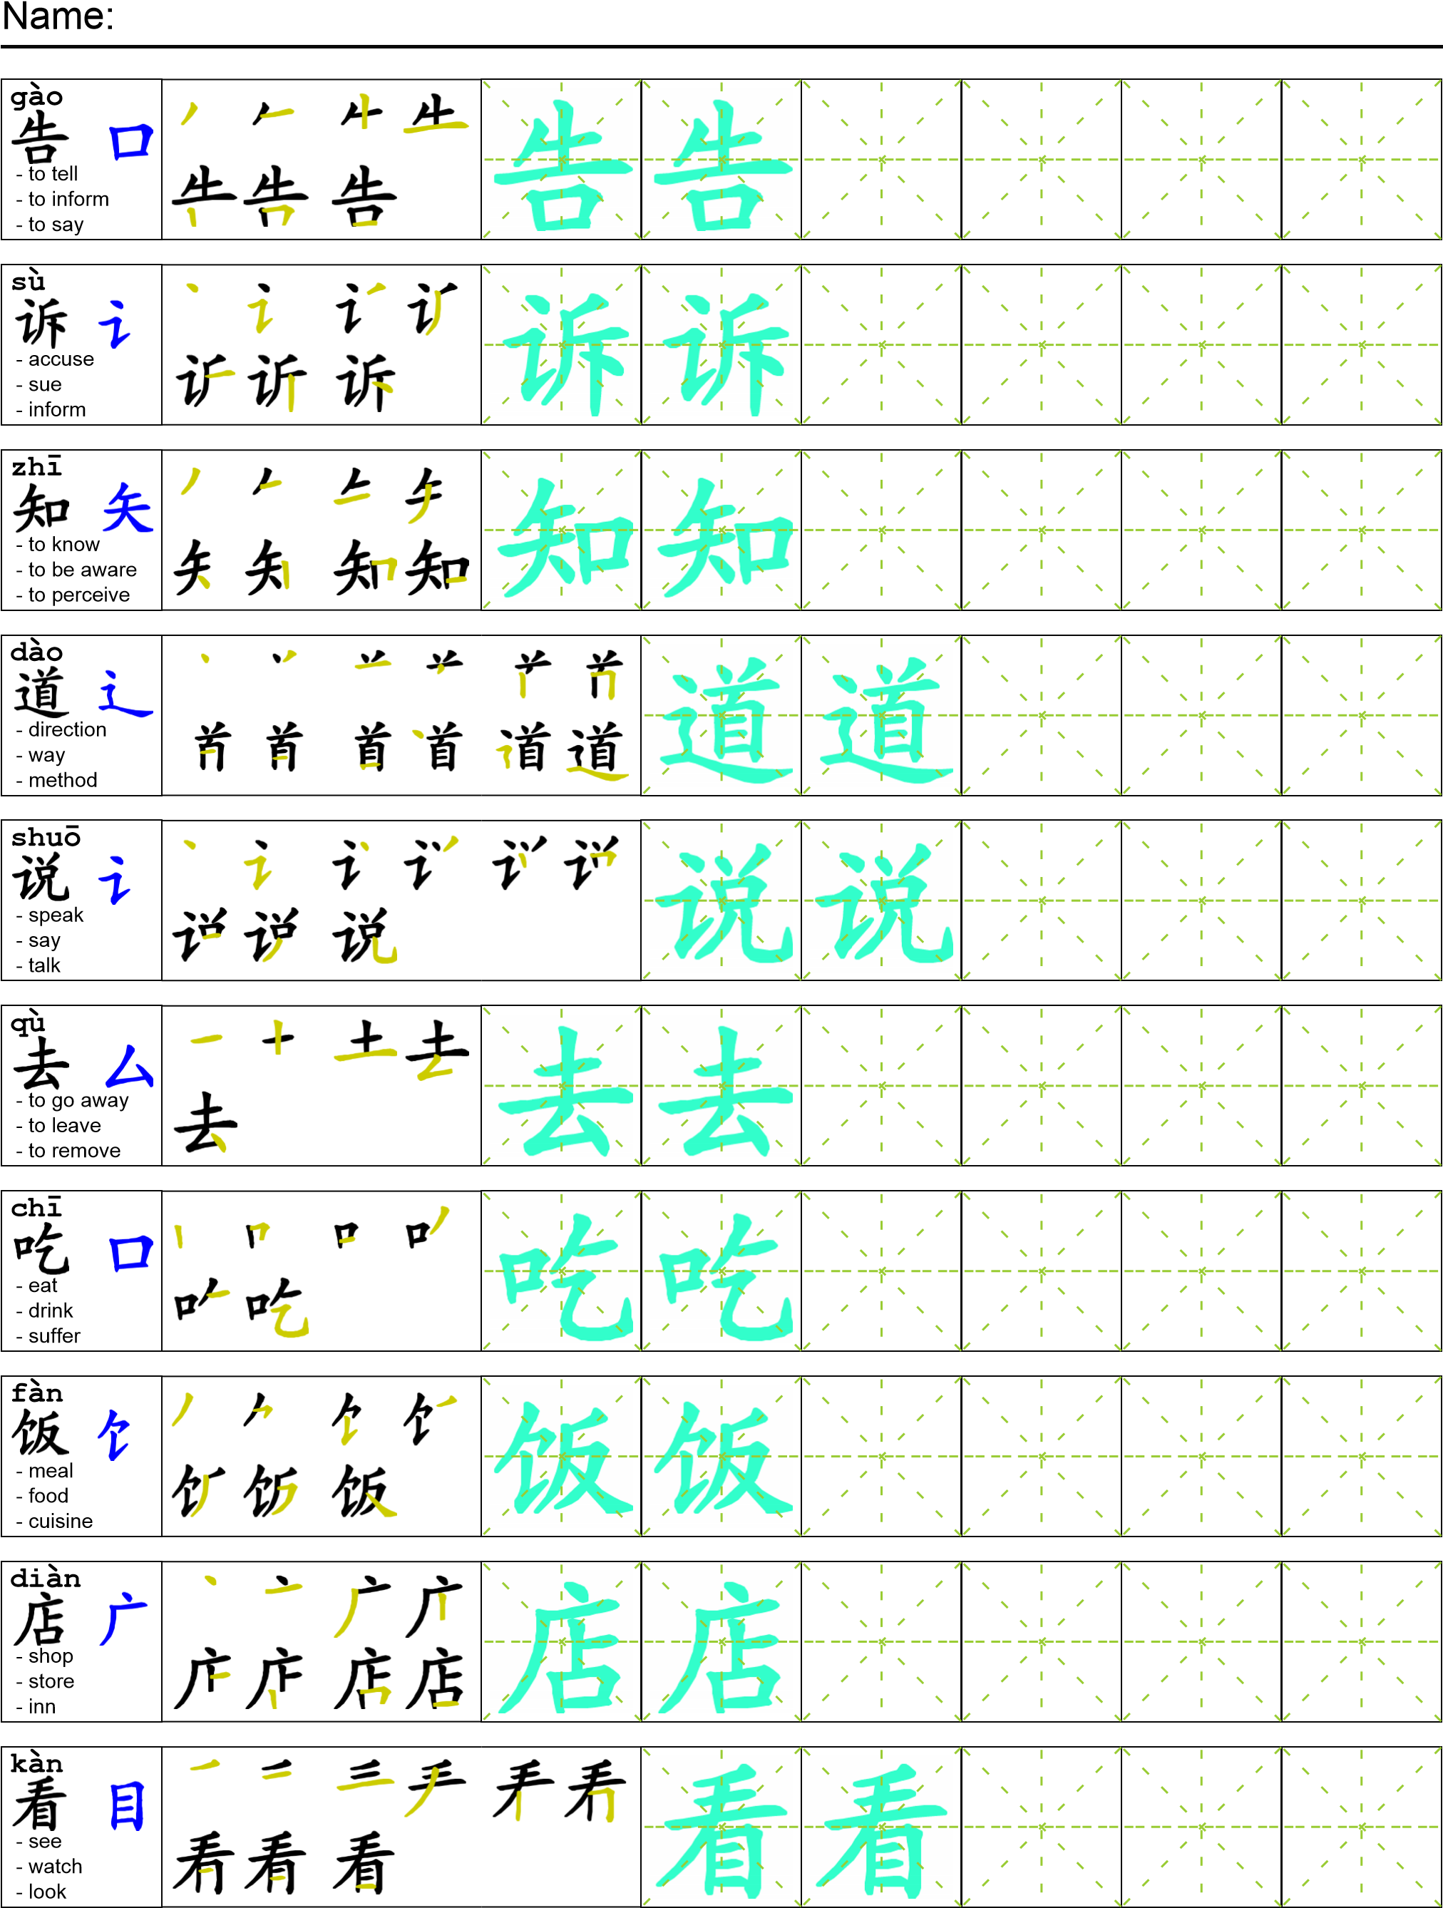
Reading

我决定告诉我妹妹，但是我不知道她在哪？我去了学校，但是她的老师说我妹妹去吃饭了。我去了饭店，但是老板说她走了。老板说她看起来快生病了。所以我去了医院。在医院我终于找到了她。

Task Completion

Once all tasks are complete turn the assignment in to collect the points for the project.
Task 1: Trace the vocabulary and copy text into your notebook.

Task 2: Answer Comprehension Questions.

Task 3: Write the Pinyin for the Reading.

Task 4: Translate the Reading into English.

Task 5: Record yourself reading the passage.

Comprehension Questions
- Where did the author first go to find his sister? _________________________________
- Where did the author finally find his sister at? __________________________________
- What character in this passage means “where”? ________________________________
- How would you write the word for bookstore? _________________________________

